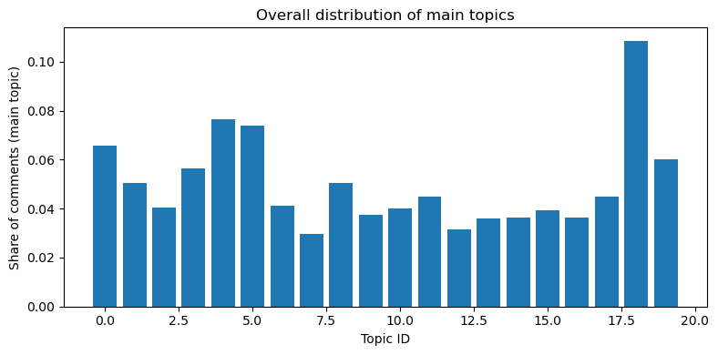
Figure X. Overall distribution of main topics across all comments.
Each bar shows the share of comments whose main LDA topic is a given theme (e.g., Immigration, Elections, Trump, Israel). This summarizes which political issues dominate the comment section and highlights that immigration is only a small fraction of the overall discussion.
"Immigration", # Topic 0: border, illegal, drugs, immigration over the years
"Humanity", # Topic 1: people, children, life, killing, care, human lives
"Biden", # Topic 2: Biden, administration, ATF, congressman, thanking
"Taxation", # Topic 3: money, taxes, funding, government spending
"Praise", # Topic 4: love, great job, good work, Speaker Johnson
"Opinions", # Topic 5: people’s thoughts, stupid, guys, things, reactions
"Lies", # Topic 6: lies, hate, media, woke, liberals, ignoring facts
"War", # Topic 7: war, military, weapons, China, Russia, Ukraine
"Elections", # Topic 8: voting, elections, parties, political identities
"Law", # Topic 9: law, rules, federal and state government, courts
"Trump", # Topic 10: Trump, president, MAGA, RINOs, Cheney, Biden
"Questioning", # Topic 11: questions, answers, crime, charges, jail, hearings
"Israel", # Topic 12: Israel, Hamas, terrorism, Palestine, USA support
"Safety", # Topic 13: roads, guns, schools, blocks, work, home safety
"Religion", # Topic 14: God, bless, evil, Jesus, Amen, praying
"Energy", # Topic 15: power, energy, electricity, oil, gas, climate
"Viewing", # Topic 16: watching videos, comments, reading, information
"Patriotism", # Topic 17: America, rights, citizens, states, government
"Conversation", # Topic 18: saying, talking, knowing, looking, something
"Partisanship" # Topic 19: Democrats vs Republicans, getting back the House
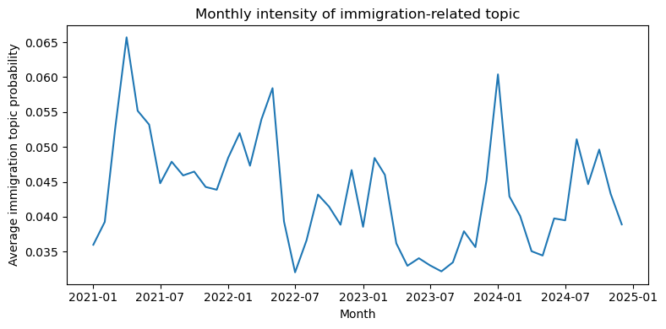
Figure X. Monthly intensity of the immigration topic.
The line shows the average probability of the immigration topic across all comments in each month. Higher values indicate months where more of the overall discussion is focused on immigration and border issues.
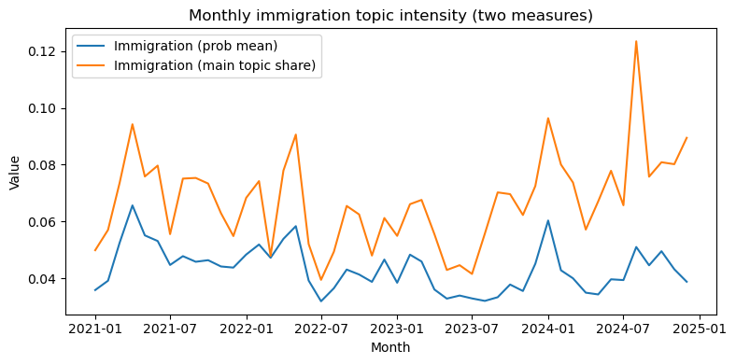
Adding the dashed line which reports the share of comments whose main topic is immigration in each month, providing a “hard assignment” version of the same pattern.
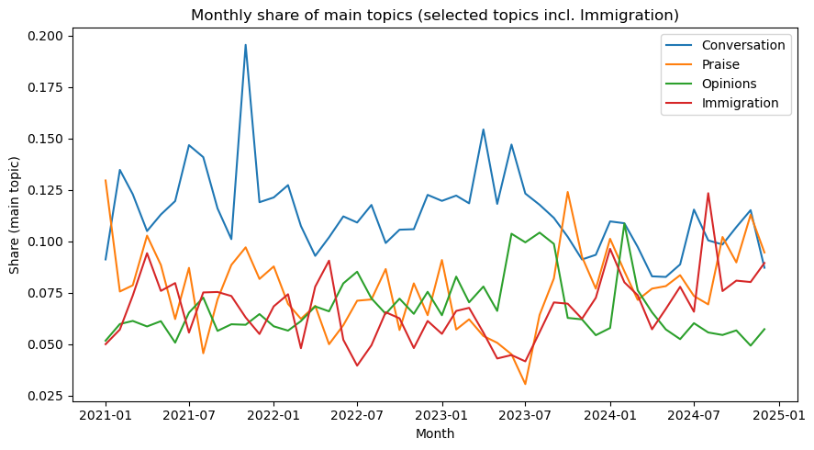
Figure X. Monthly share of main topics (selected topics including Immigration).
The figure plots the monthly share of comments whose main topic is one of several key themes (e.g., Conversation, Praise, Opinions, Immigration). Comparing these lines shows how the prominence of immigration evolves relative to other major topics over time.

